Fashion Products Classifier Using Visual Recognition

**Project Description:**

Visual classification of commercial products is a branch of the wider fields of object detection and feature extraction in computer vision, and, in particular, it is an important step in the creative workflow in fashion industries. Automatically classifying garment features makes both designers and data experts aware of their overall production, which is fundamental in order to organize marketing campaigns, avoid duplicates, categorize apparel products for e-commerce purposes, and so on. There are many different techniques for visual classification, ranging from standard image processing to machine learning approaches:

In this project you need to build a web application that checks the type of fashion product like Shirt, T-Shirt and Jeans .IBM Watson Visual Recognition services is used to build a custom model to check for the type of product. Build the web application using Node-red Service and integrate to Visual Recognition

**Services Used:**

1. IBM Watson Visual Recognition
2. Node-Red
3. IBM cloud Application

**Architecture**:

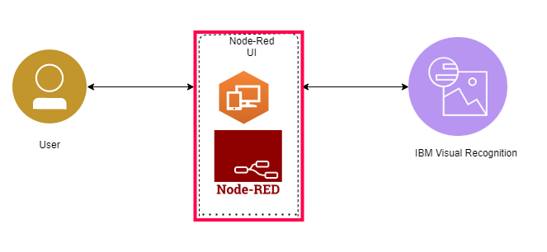

**Developer Details:**

Anu Jose

Assistant Professor

Department of Information Science

CMR Institute of Technology

Bagalore-560037

**Implementation details:**

1. Created IBM Watson account

2. Collected 3 different set of images and classified it in to 3 classes using IBM Watson studio Visual Recognition model tool box. It is used for image classification. Jeans, Shirts and T-shirts are stored in different folders with 100,135 and 87 images respectively for training. Tested the created custom model with high accuracy.

3. Node- RED is used for making a user interface for uploading the image. Based on the image content the dress will be categorized to any of the 3 classes with its confidence level value.

**Scope of the work:**

Ecommerce market’s explosive growth has created an overload of information on the users that visit the site. With the growth of online shopping, and addition of third-party sellers on selling platforms, maintaining a standard taxonomy of products is becoming more and more important to provide the users the ease to find products of their choice. This growth of ecommerce has been exponential in the past few years. Users that surf these online websites to fulfill their shopping needs come from all demographics. Be it a 60-year-old or a 6-yearold, today’s technological advancements have made it favorable for all age groups to come to a search engine, look for desired items in a category or specify what they want in text or speech, and get a list of results to choose from. The accuracy and relevance of this result list determines how happy users will be. Ecommerce giants such as Amazon, Walmart, eBay, etc. list millions of products on their websites. To present these products to users in an organized manner so as to simplify search and navigation, they are categorized into multi-level categories . For example, Electronics -> iPads and Tablets -> iPads - > Apple iPad 32 GB. This way the end product Apple iPad 32 GB falls under multiple levels of hierarchy. This sort of hierarchical taxonomy makes the pathway to reach to the desired items easier and users then know exactly where to navigate to find what they need. Ecommerce websites today do not only display their own products but also items from merchants who register as sellers on their websites. Merchants need to enter all the product information manually and not all merchants take the time and effort to do so. Also, various merchants have their own taxonomies the way they store their product information, these individual taxonomies need to be unified into a single canonical taxonomy for the website. This kind of standardization is necessary to provide users a seamless searching and shopping experience. While some products on ecommerce websites are categorized manually, this number is very small. Having millions of products on the website, it is not possible to manually categorize each and every one of them, which is why an automatic classification system becomes of utmost importance for any ecommerce website. There are different approaches that can be adopted to automate this classification. Most of the existing approaches use text in order to classify products to their respective categories. Classification done solely on the basis of text suffers from problems such as missing/incomplete text, text unrelated to product, text related to multiple categories, and Optimizing E-Commerce Product Classification Using Transfer Learning 5 inconsistent vocabulary used by different merchants. This leads to misleading information for the automation model that then classifies products in inaccurate categories.

**Screenshots**

